Medical and Behavioral Health in Shelters

Toolkit

Association of Bay Area Health Officials
Public Health Preparedness Subcommittee

April 10, 2020

Toolkit Overview

Background
This toolkit supports the provision of medical/health services in a general population shelter, which provides safe refuge and mass care services, such as feeding, case management, and health services, to individuals who are displaced by a threat or hazard.
General population shelters include individuals with behavioral health and/or chronic medical conditions who require some level of skilled medical care to:
- Maintain their usual level of health.
- Preserve independence.
- Avoid hospitalization.
In some instances, shelter residents may also require adjustments to their medication or frequent monitoring of their condition.

Intent
The Medical/Health Shelter Toolkit, authored by the Association of Bay Area Health Officials (ABAHO) with contract support from Hagerty Consulting, contains 11 tools intended to:
- Strengthen the ability of ABAHO jurisdictions to provide personnel, equipment, supplies, and technical assistance to other jurisdictions within the Bay Area.
- Address issues, challenges, and information gaps related to the provision of medical/health services in a general population shelter revealed through recent disasters.
- Improve the ability of Bay Area stakeholders to support the short- and long-term behavioral health resilience of individuals impacted by a disaster.

Scope
The Medical/Health Shelter Toolkit:
- Supplements disaster medical services and mental/behavioral health plans, policies, and procedures developed by local, state, and federal agencies and organizations.
- Focuses specifically on the medical/health services in a general population shelter.
- Enables jurisdictions to tailor tools to reflect their jurisdiction-specific needs, as desired.
- Includes tools to be used by medical personnel in the medical/health services section of a shelter.

Implementation
Jurisdictions should consider the following when implementing this toolkit:
- This toolkit is reflective of current methodologies and approaches throughout the ABAHO region and incorporates local, regional, and national best practices.
- The toolkit provides jurisdictions with guidance to structure a medical/health section in a shelter, as there is currently no standardized regional model for a medical/health section of a shelter.
- The various tools are structured so that they may be easily adapted based on incident type and shelter management structure.

Types of Shelters and Care Sites
Different disasters may necessitate activation of several shelter types. This toolkit is intended to be utilized for general population shelters, but some content may be applicable to other types of shelters or service locations, such as those listed in the table below.
Table 1: Types of Shelters and Care Sites
Type of Shelter | Description
General Population Shelter | Congregate facilities that provide a safe, sanitary, and secure environment for individuals and households displaced by disasters. Services and resources are intended to enable shelter residents to maintain health and independence and avoid hospitalization.
Medical Shelter | Temporary housing and care for individuals with more acute medical conditions requiring monitoring and management by a credentialed medical professional.
Stand-Alone/Pop-Up Shelter | Independently operating shelter, usually without jurisdictional support.
Observational Care Site | Sufficiency-of-care model for individuals who require monitoring and management by a credentialed medical professional.
Low-Acuity Patient Care Site | Used to transfer stabilized patients from hospitals to medical shelters to alleviate hospital overcrowding.
Ambulatory Care Clinics | Provides medical care for “walking wounded” or sub-acute conditions (e.g., medication or vaccine point-of-dispensing).
Primary Triage Point | Established near an impact zone or in close proximity to a hospital to quickly evaluate patients to determine prioritization for transport to hospitals or other designated locations.
Alternate Care Site | Provides additional treatment area(s) for patients requiring advanced care; can be established in an unused hospital wing, facility of opportunity, or soft-sided structure.

Toolkit Contents
# | TOOL NAME | DESCRIPTION
1 | Assessment Form for Medical/Health Needs | Recommended procedures for medical/health-specific screening during the shelter registration and intake process.
2 | Triage Decision Support Tools | Helps personnel determine the appropriate services and resources for clients with medical/health needs based on information collected during intake and initial screening.
3 | Medical/Health Staff Job Aids | Describes position-specific responsibilities and provides an organizational chart to illustrate the relationship of the medical/health services section to the overall shelter structure.
4 | Resource Management Considerations | Provides a list of recommended resources to support medical/health services in a shelter and outlines considerations for resource management.
5 | Transportation Protocol | Recommended procedures for identifying, procuring, and utilizing private and public transportation resources to transfer clients with medical or behavioral health needs.
6 | Medical/Health Demobilization Protocol | Reference for demobilizing medical/health components of a general population shelter.
7 | Hospital Transfer Decision Support Tool | Intended to help personnel determine disposition of clients upon discharge from a hospital.
8 | Prescription Management Protocol | Outlines recommended procedures and guidelines for managing prescriptions and pharmaceuticals in a shelter.
9 | Volunteer Onboarding Protocol | Outlines recommended procedures to mobilize, onboard, manage, and demobilize medical/health-related volunteers.
10 | Application of a Rapid Needs Assessment in Shelters | Describes best practices for application of a Rapid Needs Assessment in shelter environments.
11 | Shelter Data Collection Form | Outlines recommended procedures to assess the medical/health-related population and resource needs.

- Assessment Form for Medical/Health Needs

Purpose
The Assessment Form for Medical/Health Needs outlines recommended procedures for non-medical/health personnel to identify and recognize potential medical/health needs in shelter clients as they initially register. Intake personnel should utilize this form, along with other shelter registration and intake forms per local policy, to register shelter clients upon arrival at the shelter.
This form is designed to be used concurrently with shelter registration and intake forms, such as those developed and/or utilized by the American Red Cross, local jurisdictions and counties, and Functional Assessment Service Teams (FAST).
This form is intended to be used in conjunction with Tool 2: Triage Decision Support Tool and Tool 8: Hospital Transfer Decision Support Tool to determine if a client should be directed to the medical/health services section of the shelter, to an alternate care site or skilled nursing facility, or to a hospital for more serious medical needs.

Considerations
During completion, personnel should consider the following:
- If the client requires communications support (e.g., language interpretation, assistance understanding or answering questions), end the interview and contact the shelter manager for additional support.
- If the client appears to be a threat to self or others, call 9-1-1 and notify the shelter Behavioral Health Lead.
- If the client’s behavioral health status begins to decline during the assessment (e.g., if the discussion exacerbates trauma or stress from incident), end the interview and refer the individual to a member of the shelter behavioral health support team.
- It is recommended that a trained medical staff member, such as an Emergency Medical Technician (EMT), is present at initial shelter intake to advise on medical concerns/considerations that may appear as individuals present at the shelter.
- It is recommended that a trained disaster behavioral health staff member is present at initial shelter intake to inconspicuously assess and refer individuals with behavioral health support needs to other behavioral health staff in the shelter. The typical emotions disaster survivors experience, such as shock, grief, anger, and sadness, are normal, and shelter behavioral health staff members can provide support services to help the individual cope with the new situation, reduce initial distress, and foster short and long-term adaptive functioning and resilience.

Assessment Form
Table 2: Assessment Form
Contact Information
Name:
Phone:
Email
Address:
Initial Medical/Health Screening
Does the client need assistance hearing, understanding, or answering these questions? |  |  | Yes No
Is the client currently ill (e.g., vomiting, diarrhea, too weak to stand)? |  |  | Yes No
Does the client need first aid or have any obvious physical injuries? |  |  | Yes No
Does the client require support to administer medications (e.g., no caregiver present)? |  |  | Yes No
Is the client on any medications or use medical devices that require refrigeration or other special storage/administration mechanisms (e.g., insulin, nebulizer, oxygen)? |  |  | Yes No
Is the client currently undergoing dialysis? |  |  | Yes No
Does the client seem confused? |  |  | Yes No
Does the client appear to be overwhelmed, disoriented, or agitated? |  |  | Yes No
Acute Needs Screening
If the response to any of the questions in this section is “yes,” call 9-1-1.
Is the client having chest pain or difficulty breathing? |  |  | Yes No
Is the client experiencing vision problems (e.g., double or blurry vision)? |  |  | Yes No
Does the client appear to be disoriented? |  |  | Yes No
Is the client having trouble speaking? |  |  | Yes No
Does the client appear to be a threat to self or others? |  |  | Yes No
Hospital Transfer Information (If Applicable)
Transferring Facility:
Medical Condition(s):
Infection Control Issues:
Patient Risk Alerts:
Treatment Devices:

- Triage Decision Support Tools

Purpose and Instructions
The Triage Decision Support Tools are intended to help triage and first aid personnel identify acute, urgent, and non-urgent medical needs in shelter clients during registration. It is recommended that a medical professional (e.g., EMT) be staged at intake to advise completion of medical-related elements and that a behavioral health representative be available for behavioral health-related elements.
These tools are intended to be used by triage and first aid personnel in conjunction with Tool 1: Assessment Form for Medical/Health Needs to determine if a shelter client should be directed to the medical/health services section of the shelter, to Mental/Behavioral Health Personnel, to an alternate care site or skilled nursing facility, or to a hospital for more serious medical attention.

Medical/Health Triage Decision Support Tool
Figure 1 should be used to determine the needs of non-acute and acute medical needs.
- Non-acute medical care refers to specialized, multidisciplinary care in which the primary need for care is optimization of the patient’s functioning and quality of life.
- Acute medical care refers to short-term treatment for an injury, episode of illness, or an urgent medical condition. Acute conditions are often severe and come on suddenly, but do not last long.
Figure 1: Medical/Health Triage Decision Support Tool
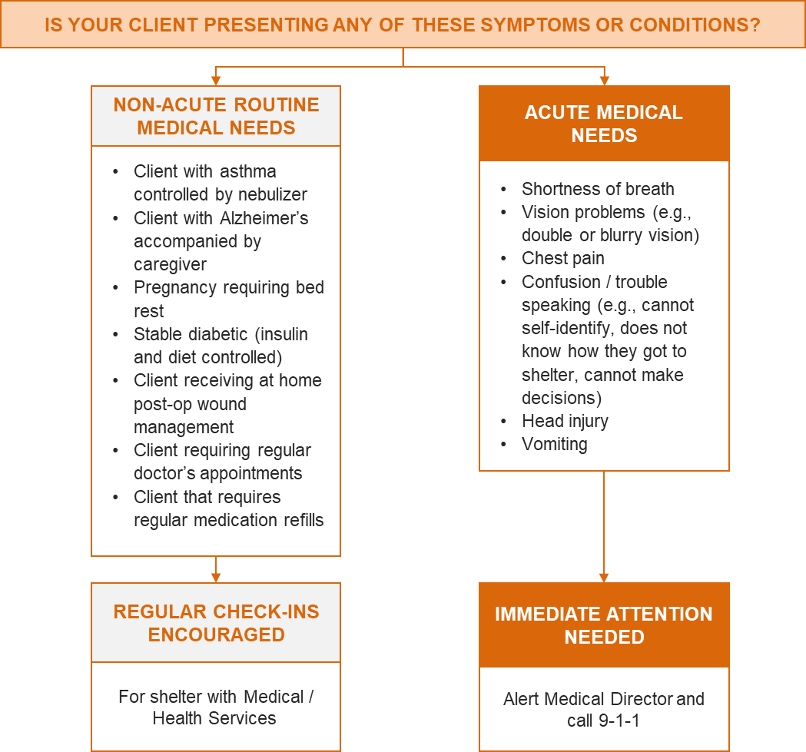

Behavioral Health Triage Decision Support Tool
Behavioral health symptoms may require specialized assistance from Mental/Behavioral Health Personnel and/or 9-1-1. Figure 2 should be used to determine whether or not a shelter client requires mental or behavioral health attention.
Figure 2: Behavioral Health Triage Decision Support Tool

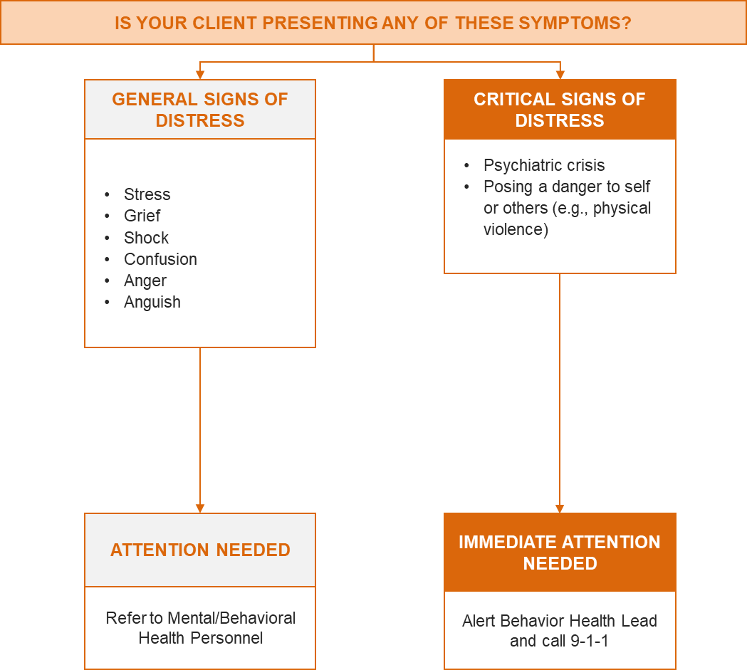

- Medical/Health Staff Job Aids

Purpose and Instructions
The Medical/Health Staff Job Aids outline position-specific responsibilities for medical/health shelter positions and an organizational chart to illustrate the relationship of the medical/health section to the overall shelter structure.
The job aids—informed by and adapted from the Alameda County Health Care Services Agency Job Action Sheets and the National Emergency Management Agency Mission Ready Packages—are intended to be a resource for medical/health staff to reference in preparation for working in a general population shelter.
This tool is intended to be adapted and scaled as appropriate for individual jurisdictions. Two potential organizational structures are depicted, including a minimalist or streamlined option for smaller shelters or jurisdictions with limited public health resources.

Position Activation Considerations
Shelter managers, Emergency Operations Center (EOC) managers, or other decision makers may choose to activate some, or all of the positions described below. Staff numbers, job titles, and functions may be altered to accommodate shelter-specific needs as well as client and staff capacity.
- The skill levels and the medical supplies/equipment available will determine the level of medical care that can be provided. Shelters may combine functions such as screening and first aid.
- In a general population shelter with population more than 50 but less than 100 people, one medical/health staff member should be on site at all times and one mental health staff member should be available by phone.
- In a general population shelter with less than 50 people, medical/health and mental health staff should be available at check-in. Beyond the check-in phase, medical/health and Mental/Behavioral Health Personnel should be accessible by phone to field any questions from the shelter manager.
- When more than 30 percent of the shelter population has access and functional needs, disability, activities of daily living support needs, or chronic condition management support needs, the medical/health staffing structure should expand in relation to the size of the shelter population and the shelter population’s demonstrated needs.

Lean Model for Shelter Staffing
These operational models represent a “lean” or streamlined model for staffing shelters with low capacity and/or to be used by jurisdictions with limited resources. The Medical Support Team and Clinical Support Team concept is adapted from the National Emergency Management Association (NEMA) standardized Mission Ready Package (MRP) and is intended to work in conjunction with one another to support shelter clients’ medical/health needs.

Clinical Support Team
The primary goals of the Clinical Support Team are to provide medical supervision and services for all general population shelter clients (including individuals requiring specialized medical and functional needs support services) and to support administrative medical functions including:
- Ensuring prescriptions are filled
- Administering medication
- Treating minor wounds
- Monitoring glucose in shelter clients
Figure 3: Clinical Support Team Organizational Model

Shelter Manager
Team Lead
Registered Nurse (RN)
Emergency Medical Technician (EMT)
Emergency Medical Technician-Paramedic (EMT-P)
Administrative
Assistant

Medical Support Team
The primary goals of the Medical Support Team are to provide medical supervision/services for all general population shelter clients, including individuals requiring specialized medical and functional needs support services.
Figure 4: Medical Support Team Organizational Model

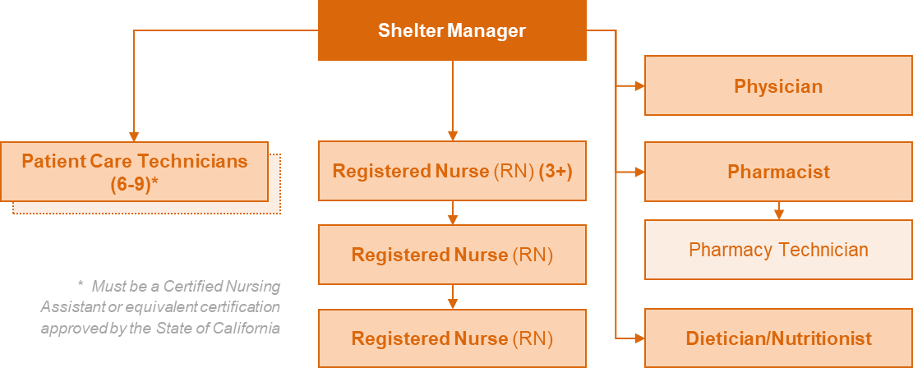

Expanded Model for Shelter Staffing
This organizational model is most compatible with shelters serving over 100 clients. This model can be utilized as it appears in Figure 5 or tailored as needed for individual jurisdiction or shelter needs. The white boxes represent positions whose functions may overlap and could be collapsed into fewer positions that align with the jurisdiction’s specific capabilities.
Figure 5: Expanded Organizational Model for Shelters
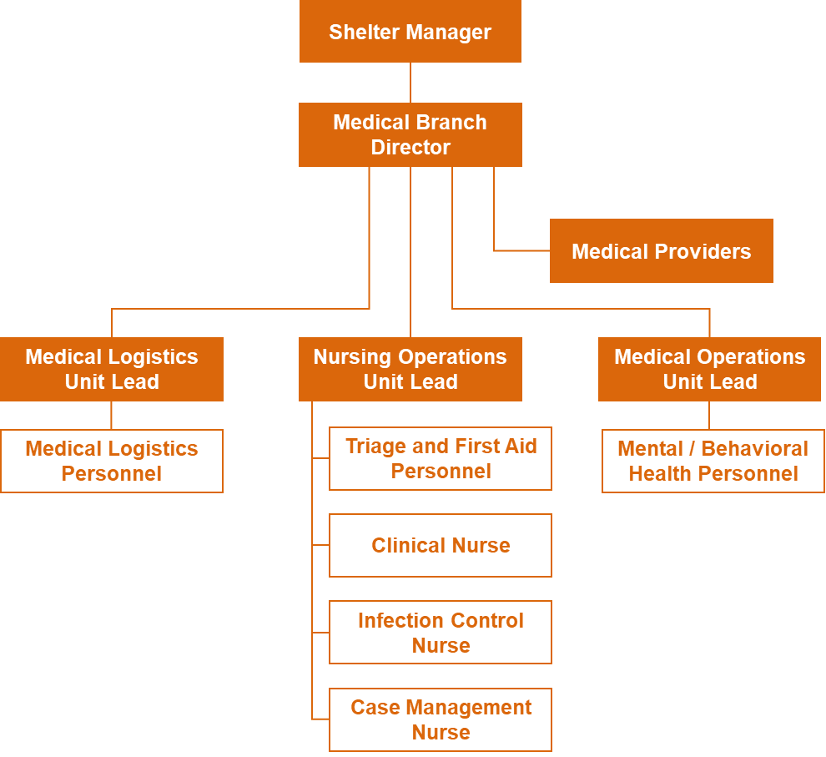

Job Aids

Job aids for “core positions” are linked below.
- Medical Branch Director (may also be referred to as “Medical Operations Manager”)
- Medical Logistics Unit Lead
- Medical Operations Unit Lead
- Medical Provider
- Medical Logistics Personnel
- Nursing Operations Unit Lead
- Case Management Nurse
- Clinical Nurse
- Triage and First Aid Personnel
- Infection Control Nurse
- Mental/Behavioral Health Personnel
Medical Branch Director
Reports to: Shelter Manager or Emergency Operations Center Manager
REPORTING
GUIDANCE
Medical Operations Unit Lead
PERSONAL PROTECTIVE EQUIPMENT PROTOCOLS
tasks
- Set-up and maintain medical/health services areas.
- Designate Medical/Health Section personnel respite areas.
- Document actions and decisions on a continual basis
- Document unit actions and decisions on a continual basis.
- Address issues related to client care including:
  - Ongoing client arrival and bed availability
  - Client transfers and tracking
  - Mental health for clients, families, staff, and incident management personnel
  - Medications
  - Linkages with the medical community, area hospitals, and other healthcare facilities
- Address issues related to medical/health services operations including staff health and safety; staffing; medical equipment and supplies; and personnel and resource movement.
- Ensures Medical/Health Section personnel perform only those duties consistent with their level of expertise and only according to their professional licensure.
- Oversee appropriate level of medical/health services provided in the shelter site based on available staff, equipment, and supplies.
Reports to: Medical Branch Director
- ICS 201: Incident Briefing
- ICS 213: General Message
- ICS 214: Activity Log
- [Placeholder for PPE protocol, if necessary]
Roles and Responsibilities
- Notify Emergency Support Function (ESF)-8: Public Health and Medical when the medical/health services section is operational.
- Ensure the ICS 214: Activity Log is maintained.
- Ensure all shelter reports are completed and forwarded to shelter management and ESF-8.
- Coordinate with ESF-8 for the placement of clients identified as needing a higher level of care than is available at the general population shelter.
- Manage order process for prescriptions, onsite storage and security of prescriptions, dispensing of prescriptions, and disposal of unused medications.
- Ensure the medical and clinical staff perform only those duties consistent with their level of expertise and only according to their professional licensure.
- Receive instruction from Shelter Manager regarding demobilization activation timelines and report details to the medical/health services section Unit Leads.
Reporting Guidance
- ICS 201: Incident Briefing
- ICS 213: General Message
- ICS 214: Activity Log
- Patient Care Documents

Medical Logistics Unit Lead
Reports to: Medical Branch Director / Medical Operations Manager

Roles and Responsibilities
- Provide oversight for Medical Logistics Unit personnel and resources.
- Coordinate functions of the Medical Logistics Unit.
- Implement a system for marking, tracking, and returning client equipment, supplies, and medication(s).
- Familiarize staff with shelter floor plan.
- Set up medical/health services section triage/screening, including posting of signs and setting up of tables and chairs.
- Ensure that all staff receive incident-specific just-in-time training.
- Coordinate with Nursing Operations Unit Lead to ensure infection control/isolation areas are maintained and functional, including ensuring area is secure and separated from general population areas to prevent the spread of disease.
Reporting Guidance
- ICS 201: Incident Briefing
- ICS 213: General Message
- ICS 214: Activity Log
- Patient Care Documents

Medical Operations Unit Lead
Reports to: Medical Branch Director / Medical Operations Manager

Roles and Responsibilities
- Set-up and maintain medical/health service section areas.
- Designate medical/health service section personnel respite areas.
- Document actions and decisions on a continual basis.
- Document unit actions and decisions on a continual basis.
- Address issues related to client care including:
  - Ongoing client arrival and bed availability
  - Mental health for clients, families, and personnel
  - Communications with the medical community, area hospitals, and other healthcare facilities.
- Address issues related to medical/health services operations including staff health and safety; staffing; medical equipment and supplies; and personnel and resource movement.
- Ensure medical/health services section personnel perform only those duties consistent with their level of expertise and only according to their professional licensure.
- Oversee appropriate level of medical/health services provided in the shelter site based on available staff, equipment, and supplies.
Reporting Guidance
- ICS 201: Incident Briefing
- ICS 213: General Message
- ICS 214: Activity Log
- Patient Care Documents

Roles and Responsibilities
- Conduct the medical assessment and treatment of clients, including medication administration, medication refill, and basic assessment/treatment for common medical concerns.
- Perform secondary assessment/triage on clients needing a higher level of assessment.
- Discharge clients to higher levels of care, as needed.
- Monitor clients with chronic illnesses and provides supportive measures (e.g., asthma-albuterol treatment, blood sugar checks, wound care, dressing changes).
- Maintain the clients’ medical update form and advise the Medical Branch Director of any adverse client condition changes.
Reporting Guidance
- ICS 201: Incident Briefing
- ICS 213: General Message
- ICS 214: Activity Log
- Patient Care Documents
Medical Provider
Reports to: Medical Branch Director
Must be a licensed health care provider (e.g., RN, NP, DO, PA, DDS, MD)

Medical Logistics Personnel
Roles and Responsibilities
Reports to: Medical Logistics Unit Lead
- Oversee supply chain requests pertinent to the medical/health services section in conjunction with the Logistics Section of the overarching shelter.
- Support registration and intake of shelter clients.
- Identify, order, receive, and set-up medical supplies and equipment.
- Monitor supply usage and ensure timely replenishment of all materials.
- Ensure supplies are stocked and distributed for clients in infection control/isolation area.
- Assign and orient staff, as necessary.
- Identify resource needs (e.g., computer, phone, plan, procedures).
- Address needs such as communications, provision of food and water for staff, and transportation resources.
- Address credentialing needs as necessary.
- Maintain medical records.
- Support the Pharmacist in prescription management needs.
Reporting Guidance
- ICS 201: Incident Briefing
- ICS 213: General Message
- ICS 214: Activity Log
Nursing Operations Unit Lead
Reports to: Medical Branch Director
Roles and Responsibilities
- Coordinate shift assignments and provide oversight of activities in the medical/health services section.
- Perform all duties of the Clinical Nurse, as needed:
  - Observe and record client behavior.
  - Perform physical exams and diagnostic tests.
  - Collect patient health histories.
  - Educate patients about treatment plans.
  - Administer medications, wound care, and other treatment options.
  - Interpret patient information and make decisions about necessary actions, where appropriate.
- Delegate responsibilities to a Nursing Shift Lead as needed.
Reporting Guidance
- ICS 201: Incident Briefing
- ICS 213: General Message
- ICS 214: Activity Log

Case Management Nurse
Reports to: Nursing Operations Unit Lead

Roles and Responsibilities
- Collaborate with client care providers to create an integrated, continuous treatment care plan.
- Interact with every medical/health services section client to ensure comprehension of care plan.
- Coordinate with clients’ external service providers, such as physicians’ offices, pharmacies, or dialysis units.
- Manage medical appointments, support treatment and monitoring plan, support transition of clients with medical needs into shelters, by hand if necessary.
Reporting Guidance
- ICS 201: Incident Briefing
- ICS 213: General Message
- ICS 214: Activity Log
- Patient Care Documents

Clinical Nurse
Reports to: Nursing Operations Unit Lead

Roles and Responsibilities
- Observe and record client behavior.
- Perform physical exams and diagnostic tests.
- Collect patient health histories.
- Educate patients about treatment plans.
- Administer medications, wound care, and other treatment options
- Interpret patient information and make decisions about necessary actions, where appropriate.
Reporting Guidance
- ICS 201: Incident Briefing
- ICS 213: General Message
- ICS 214: Activity Log
- Patient Care Documents

Triage and First Aid Personnel
Reports to: Nursing Operations Unit Lead
Roles and Responsibilities
- Perform primary assessment/triage on shelter clients seeking medical care.
- Make recommendation of if level of care needed can be provided within the shelter medical/health services section.
- Provide basic first aid and administer medication for existing illnesses based on available medications.
- Ensure client or guardian has signed consent form before care is rendered.
- If higher level of medical care is needed, direct client to the medical/health services section.
- Document care provided on the client records, including any care received prior to registration at shelter (for hospital transfers).
Reporting Guidance
- ICS 201: Incident Briefing
- ICS 213: General Message
- ICS 214: Activity Log
- Patient Care Documents

Infection Control Nurse
Reports to: Nursing Operations Unit Lead
Roles and Responsibilities
- Assist in conducting needs assessment, performing surveillance, monitoring infection control practices, and intervening during potential infectious disease outbreaks.
- Operate isolation and quarantine functions.
- Assign referrals to isolation or quarantine category and provide care in the infection control/isolation area of the section, as needed.
- Monitor clients for infectious disease transmission.
- Manage medical care for clients in isolation area.
- Ensure client areas, including cots, are properly disinfected.
- Ensure medical waste is properly disposed.
- Review relevant protocols, procedures, and guidelines with Nursing Operations Unit Lead.
- Determine staffing needs based on the number of referrals and acuity of clients.
Reporting Guidance
- ICS 201: Incident Briefing
- ICS 213: General Message
- ICS 214: Activity Log

Mental / Behavior Health Personnel
Reports to: Medical Operations Unit Lead

Roles and Responsibilities
Mental/Behavioral Health Personnel will perform various function-based support services, such as:
- Conduct monitoring and surveillance in an informal manner to ensure residents feel comfortable and that they are not being “analyzed”.
- Walk around the shelter and surrounding areas (e.g., parking lot) engaging in simple conversations with residents while utilizing screening methods described in this document or of their choice.
- Deliver psychological first aid as soon as possible for residents exhibiting stress and determine whether a referral or an emergency intervention is needed.
- Provide instructions to shelter staff on what behaviors, words, and physical symptoms may indicate a resident needs assistance and the process for informing the behavioral health staff.
- Collect information on the general mental health trends of the shelter population through interaction with the shelter residents to drive the overall behavioral health strategy across the disaster operation.
Consult the ABAHO Behavioral Health Concept of Operations for details about each role.
Reporting Guidance
- ICS 201: Incident Briefing
- ICS 213: General Message
- ICS 214: Activity Log

- Resource Management Considerations

Purpose and Instructions
The Resource Management Considerations Tool provides a list of recommended resources, including personnel, equipment, supplies, and pharmaceuticals commonly needed in medical/health services sections of general population shelters.
This tool also includes resource management considerations to assist medical/health services staff with managing equipment and supplies resource concerns. For additional details on resource management procedures, defer to the California Public Health and Medical Emergency Operations Manual (EOM).
This tool should be used by Medical Logistics Personnel and other local public and medical health subject matter experts to enhance resource management in the medical/health services sections of general population shelters.

Common Supplies Resource Needs List
The Common Supplies Resource Needs List is a basic list of medical resources that may be needed in general population shelters, including durable medical equipment (DME) and consumable medical supplies.
The Medical Logistics Unit Lead can utilize this list to identify potential medical/health resources in general population shelters and can be adjusted as needed when determining what resources are needed for the anticipated shelter population within the medical/health services section.
Refer to accompanying spreadsheet to see list (pictured below).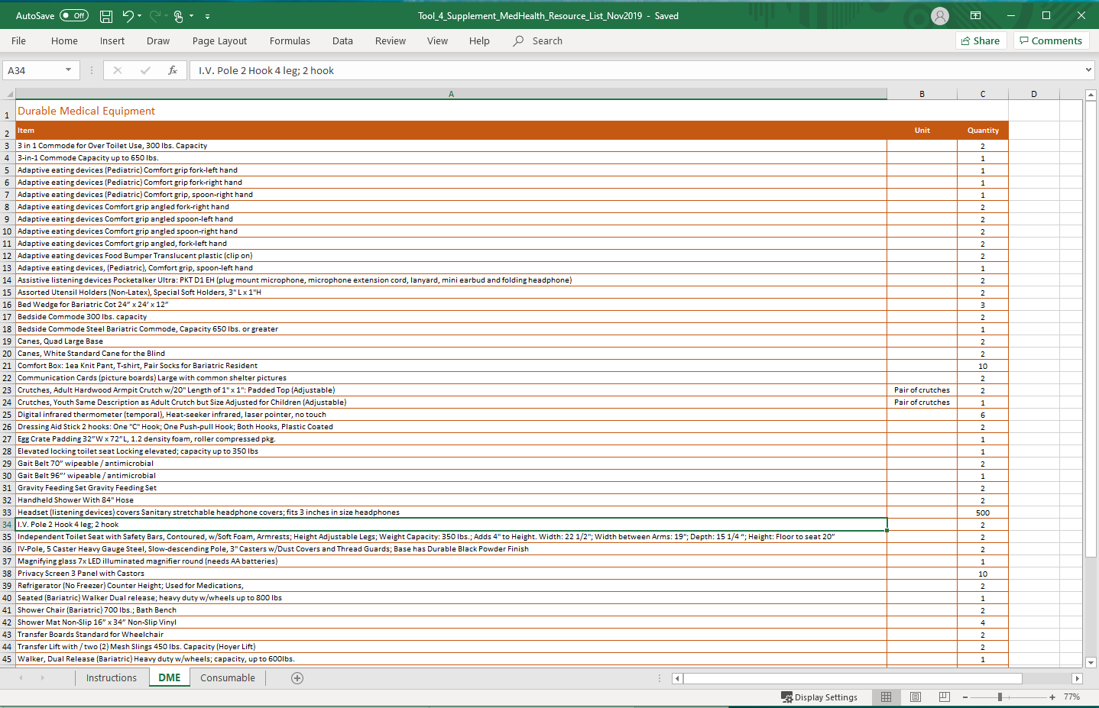

Resource Management Considerations
The following resource management considerations outline recommendations for planning, mobilizing, tracking, reporting, and demobilizing personnel and equipment resources within a general populations shelter. These recommendations should be considered in conjunction with procedure guidance from the American Red Cross, the California Public Health and Medical Emergency Operations Manual, local and state emergency plans, and Incident Command System (ICS) protocol.
Planning
- In consultation with the American Red Cross, Logistics should assess available medical/health resources.
- Medical Logistics Personnel will utilize local and state emergency operations plans and local public, medical, and mental health subject matter experts to determine what health and mental health agencies/organizations will be approved to provide services in the shelter.
- The Medical Logistics Unit Lead should contact the Emergency Operations Center to understand anticipated population demographics (e.g., residents from nursing homes, hospitals, group homes).
- Public Health Planners should develop training for Emergency Operations Center personnel and shelter staff on resource request processes for resources required to support individuals with medical needs in shelters.
Mobilize
- To avoid overstaffing and oversupply issues, Medical Logistics Personnel should identify and pre-stage equipment and personnel needs for both planned and spontaneous shelters.
- Organizations or vendors that agree to provide medical equipment or supplies to an affected jurisdiction should arrange for the material to be staged for shipment. Additionally, they should provide detailed delivery information such as delivery contact information, location and time, special delivery requirements, etc.
- To effectively mobilize medical and health resources, the Emergency Operations Center should complete the Resource Request: Medical and Health Form.
Track and Report
- The Medical Logistics Unit Lead should use the Resource Request: Medical and Health Form or ICS 213 RR: Resource Request Message, depending on jurisdictional processes, to track and report resource requests submitted to the Emergency Operations Center.
- If medical/health resources are needed that cannot be obtained through existing agreements, the Emergency Operations Center will process resources requests through the Medical Health Operational Area Coordinator (MOHAC) Program in accordance with local policies and procedures.
- The providing agency and/or organization should track all resources sent to the requesting Operational Area, including the condition of the resource and anticipated return dates/times. The providing agency and/or organization should also provide burn rates for equipment and daily costs for personnel.
Recover and Demobilize
- Upon shelter demobilization, the Medical Logistics Unit Lead will utilize ICS Form 221: Demobilization Check-Out and send the form to the Emergency Operations Center.
- Equipment and supplies should be demobilized according to local plans, polices, and procedures, which may include the return of resources to vendors, suppliers, warehouses, or other originating sources.
- Deployed personnel should be demobilized and follow check-out procedures according to local policies and procedures.
Inventory
- Jurisdictions should review the resources in their shelter caches and ensure that the resources can meet the needs of shelter clients, including those with access and functional needs.
- Transportation Resources

Purpose and Instructions
The Transportation Resources tool supports shelter staff in identifying and fulfilling transportation requirements to transfer clients with medical or behavioral health needs from the general population shelter to an alternate facility (e.g., hospital). Requirements should always be submitted to local/county emergency management agencies to source transportation resources based on what is available and appropriate. This tool is intended to aid public health/shelter planners in identifying and accessing transportation resources.

Information Collection Tool
This section will be used to aid shelter staff in identifying and gathering key information to relay to emergency managers or 911/dispatch in order to source the correct transportation resource for the individual in question.
Table 3: Information Collection Tool
Information Collection Tool for Transportation Decisions
Client Information
Transport Reason | Emergency Non-Emergency
Primary Medical Complaint
Age
Gender
Weight (approximate, if unknown)
Access and Functional Needs
Additional Transport Considerations
Number of people to be transported (i.e., caregivers, parents/guardians, dependents)
Shelter Information
Shelter Address
Specific entrance or pickup area for vehicle?
Other Pickup Considerations

- Medical/Health Demobilization Protocol

Purpose and Instructions
The Demobilization Protocol is a reference for demobilizing the medical/health services section of a general population shelter. The tool is intended to aid the Unit Leads in demobilization planning and operations.

Medical/Health Demobilization Protocol
Initiation of demobilization is dependent on the unique needs of a particular shelter and disaster event. The shelter manager will communicate details regarding demobilization timing to the Medical Branch Director, who is responsible for reporting said details to the medical/health services section Unit Leads.
To prepare for demobilization, the Medical Operations Unit Lead, Medical Logistics Unit Lead, and Nursing Operations Unit Lead should utilize the following protocol to initiate demobilization activities.
Table 5: Medical/Health Demobilization Protocol
Demobilization of Staff and Supplies
Conduct individual staff debriefings.
Conduct After-Action Meeting to solicit feedback on lessons learned and memorialize best practices in an After-Action Report.
Inventory resources and ensure return, repair, and replenishment, as appropriate.
Conduct jurisdictional specific-reporting, as necessary.
Prepare financial documents for invoicing.
Continuity of Care and Case Management
Determine final disposition of all medical/health services section documentation.
Provide discharge instructions/guidance to clients with medical care plans.
Reimbursement
Collect and organize receipts, invoices, medical/health staff and volunteer hours, and daily activity reports (e.g., ICS 214, W-9, mileage reimbursement).
Submit documentation to jurisdiction and/or state, in accordance with reimbursement requirements.

- Hospital Transfer Decision Support Tool

Purpose and Instructions
The Hospital Transfer Decision Support Tool is intended to help personnel determine the disposition of clients upon discharge from a hospital (e.g., shelter, skilled nursing facility, private residence with home health agency) and prevent the transfer of patients with advanced medical needs into shelters. Additionally, it serves to eliminate client transfer to a shelter before determining whether or not the shelter has the capacity to receive each client.
Ideally, shelter personnel working in the medical/health services section will use this tool to coordinate with hospital personnel prior to patient transfer. Facilitating a conversation with hospitals in this manner will allow shelter personnel to communicate their capacity and to recommend optimal patient transfer destination and protocol. This tool should be utilized in conjunction with Tool 1: Assessment Form for Medical/Health Needs and Tool 6: Medical/Health Demobilization Protocol.

Decision Support Tool: Transfer from Hospital to Shelter
Utilize the following questions to determine disposition of clients prior to discharge from a hospital:
- Does the client have an infectious disease?
  - If yes, recommend client remain at hospital.
- What is the reason for discharge?
  - Does the client have an immediate medical or health concern?
    - If yes, recommend client remain at hospital.
    - If no, consider transfer to shelter.
  - Does the client have a life-threatening concern (threat to self or others, overwhelmed, disoriented, agitated)?
    - If yes, recommend client remains at hospital.
    - If no, consider transfer to shelter.
  - If no, what facility does the shelter recommend the hospital coordinate with?
- What are the client’s post-discharge care and treatment needs?
- What level of assistance does this client need?
  - Do transportation personnel have the capacity to transfer client with special transfer needs (e.g., ALS/BLS units, paratransit vehicles)?
- Does the shelter have the capacity to care for this client?

- Prescription Management Protocol

Purpose and Instructions
The Prescription Management Protocol outlines recommended procedures and guidelines for managing prescriptions and pharmaceuticals in a shelter. The protocol section of this tool provides strategic actions, considerations, and best practices for these areas.
This tool should be used by the Medical Logistics Unit Lead and the Medical Branch Director within the medical/health services section of a shelter. If the shelter decides to utilize a pharmacist, the Medical Branch Director may assign prescription management duties to them.
The Medical Logistics Unit Lead will only be responsible for the resource planning section below, while the Pharmacist will be responsible for the remaining protocol sections.

Protocol
Resource Planning
In smaller shelters, pharmaceutical services may be fulfilled by community providers or hospital pharmacies. If disasters heavily impact community providers, local hospitals will play a larger role in dispensing medication to shelters.
To prepare for pharmaceutical services within the shelter, the Medical Logistics Unit Lead should:
Ensure the medical/health services section is staffed with necessary pharmacy-specific equipment, including:
  - Fax/Copy machine
  - Prescription pad
  - Pill envelopes/storage
  - Medication cups
  - Oral syringes for pediatric doses
  - Pill splitters/crushers
  - Disposal containers
  - Refrigerator for medication needing storage
- Contact the Emergency Operations Center to determine the best disposal method per local health department procedures.
- Ensure all deployed pharmacy staff have appropriate refill and dispensing authorizations.

Inventory
- When possible, shelter clients are encouraged to bring their personal medications to the shelter.
- Shelters may enter into Memoranda of Understanding (MOUs) with local health departments, hospital, teaching facilities, or others to provide surge staffing.
- Maintain on-site storage and security of prescriptions.
- Maintain a separate inventory log within the pharmacy for drugs that are no longer usable and have been designated for destruction, including:
  - Name and staff member responsible for disposal
  - Date removed from inventory
  - Drug name, strength, and dosage form
  - Drug quantity
  - Reason for removal from inventory
- Report inventory log to the Medical Logistics Unit Lead upon demobilization.

Medication Distribution
- Ensure clients understand how to administer prescribed medications and offer/provide any education needed.
- Alert clients that medications do not need to be stored with pharmacy or medical clinic staff unless the client desires or the medication requires special handling such as refrigeration.
Refill/Re-Ordering
- Utilize the Pharmaceutical Refill Form to collect all necessary information for every client seeking medical refill.
  - Note: This form should only be utilized if clients do not have other means to obtain prescriptions (e.g., a family member is unable to assist them, the disaster has shut down or destroyed local pharmacies).
- Follow local and state guidelines regarding prescription capabilities within the shelter.

Medication Disposal
- Prior to proceeding with disposal methods, contact the Emergency Operations Center to receive specific guidelines or instructions regarding medication disposal practices.
  - The Emergency Operations Center may consider contacting programs (e.g., local community hospice programs) that can re-use certain medications, such as chemotherapeutic drugs.
- Follow all applicable local, state, federal, and tribal regulations and guidelines for disposal of all medication disposal.
- Dispose of old, unused, unwanted, or expired medicines (both prescription and over the counter) at a drug take back site, location, or program operated by the U.S. Drug Enforcement Administration.
- Dispose of used needles in an appropriate disposal container.
- When a controlled substance or its container is damaged in the patient care area (e.g., a tablet is dropped on the floor), it should be destroyed, documented, and reported to the Medical Logistics Unit Lead.
- All pharmaceutical disposal containers should be secured and, where possible, tethered to prevent unauthorized removal.
- Wastage should be disposed of safely and securely (in a manner that protects the public, healthcare providers, and the environment) only in designated waste containers.
- Never pour or flush any medical or pharmaceuticals down drains or toilets unless given express authority by a medical professional.
Authorization and Payment
Patient Unified Look Up System for Emergencies (PULSE)
- Work with the Emergency Operations Center to utilize PULSE to identify and fill shelter client prescription medicines. PULSE is intended to support public health nurses and volunteers with identifying health information for:
  - Patients evacuated from healthcare facilities in the affected area.
  - Injured victims transported by first responders.
  - Injured victims transported by themselves, family member, or neighbors.
  - Walking wounded presenting with minor injuries requiring treatment.
  - Evacuees seeking primary care for chronic conditions or health issues unrelated to the disaster.
- PULSE users must be granted access through the California Disaster Healthcare Volunteers, which authorizes licensed physicians, pharmacists, nurses, nurse practitioners, physician assistance, paramedics, and EMTs to access health information for treatment purposes.
Emergency Prescription Assistance Program (EPAP)
- It is recommended that EPAP be used as a last resort for pharmacy authorization and payment due to its high cost and its limited coverage.
  - EPAP allows enrolled pharmacies to process claims for prescription medications, certain medical supplies, vaccinations, and some forms of medical equipment for eligible people who live in a federally identified disaster area. It should be noted that EPAP is utilized for California residents who have no insurance.
  - EPAP is a federal program that must be requested by the State of California and is only available during a federally declared disaster situation.
  - Work with local and jurisdictional pharmacies in order register with Express Scripts to process claims under EPAP.

Other Medication Payment Options
Encourage clients to utilize other medication payment options such as:
  - American Red Cross financial assistance for co-payments and obtaining other medical supplies and equipment.
  - Local pharmacy waivers for co-payments.
Substance Abuse
- Work with the Medical Logistics Unit Lead to ensure pharmacy is supplied with Naloxone (brand name Narcan) in case of clients suffering from acute narcotics overdose.
- If a client is suffering from opioid withdrawal, they may need immediate clinical care. Call 9-1-1 and alert the Medical Branch Director.

Pharmaceutical Refill Form
This form should be completed by the Pharmacist if a shelter client requires an urgent medication refill that is not immediately available at the shelter. This form should be submitted to the Medical Logistics Unit Lead and then processed to the Emergency Operations Center, where the request will be funneled to the appropriate refill entity (e.g., local pharmacy or hospital).
The Pharmacist should maintain these forms and report all forms to the Medical Logistics Unit Lead upon demobilization. Pharmaceutical refill requests will be tracked by the Emergency Operations Center (see Tool 4: Resource Request Considerations).
Table 6: Pharmaceutical Refill Form
Patient Information
Name |  |  |  |  |  | DOB
Address |  |  |  |  |  | Phone # |  |  | Age
City |  | State |  |  |  | Zip Code
Insurance Information
Name of Insurance
Policy # or SS#
Primary Care Provider |  |  |  |  | Name/Phone #
Current Pharmacy |  |  |  |  | Name/Location
Medications Requiring Refill
Medication Name |  |  |  | Dose | Route |  | Frequency |  |  |  | Urgent
Pharmacy Information
Name
Address
Phone
Notes/Updates/Estimated Delivery Time
Transmission Information
Requested By
Submitted To
Submission Date

- Volunteer Onboarding Protocol

Purpose and Instructions
The Volunteer Onboarding Protocol outlines recommended procedures to mobilize, onboard, manage, and demobilize medical/health-related volunteers. The tool is intended to aid volunteer managers at Emergency Volunteer Centers in the onboarding of medical/health volunteers, as it is designed to be populated with deployment specific information and given to volunteers as a packet.
Additionally, shelter managers can utilize this tool to aid shelter demobilization protocols and inform after-action reporting. This tool can be utilized in conjunction with Emergency System for Advance Registration of Volunteer Health Professionals (ESAR-VHP) to provide efficiency for the onboarding process. Jurisdictions should consider utilizing this database to make the volunteer onboarding protocol clear and efficient.

Protocol
Pre-Deployment Assessment
- Administer the Pre-Deployment Assessment to medical/health volunteers prior to dispatching/deploying the individual to the shelter.
- Review each assessment upon completion to determine if each volunteer is mentally and technically fit to deploy to a shelter environment.
Dispatch Instructions
- Provide approved volunteers with dispatch instructions, including:
  - Overview of incident
  - Time and location for staging, check-in, and/or credentialing
  - Items to bring, including personal items and position-specific supplies
  - Overview of their assignment and who they report to
  - Just-in-time training opportunities (e.g., Incident Command System online courses)
  - Length of deployment
  - Technology requirements (e.g., mobile phone, additional communications equipment)
  - Information about meals
  - Travel arrangements (to/from shelter)
  - Lodging information
Onboarding
- Utilize local Emergency Volunteer Centers to manage and deliver volunteer onboarding and all other volunteer information.
- Facilitate credentialing/vetting for volunteers who have successfully completed the Pre-Deployment Assessment.
- Inform volunteer of safety considerations.
- Describe reporting requirements, including shift change procedures.
  - Instruct volunteer on the use of an ICS 214: Activity Log to track daily activities and how to submit completed forms (e.g., email, hard copy).
Demobilization
- Conduct staff debriefing to identify lessons learned and memorialize best practices.
- Ensure secure packaging of equipment and supplies.
- Conduct medical/health services section clean-up efforts, as needed.
- Ensure that all equipment temporary loaned to volunteers is returned.
- Administer a Post-Deployment Assessment to volunteers prior to exiting the shelter.
- Provide volunteers with information about Critical Incident Stress Management resources and services.

Sample Pre-Deployment Assessment
The Pre-Deployment Assessment should be distributed by volunteer managers at Emergency Volunteer Centers and completed by all medical/health volunteers prior to dispatching/deploying to a shelter. Upon completion, volunteers will submit their forms to their designated volunteer manager. Volunteer managers will use this assessment to determine if volunteers are adequately prepared to operate within a shelter environment.
Table 7: Pre-Deployment Assessment
Statement | Agree | Disagree
Please mark one option (agree or disagree) for each statement.
I have previous experience with deploying for disasters.
I can work with individuals who are experiencing significant grief and loss and who may be expressing reactions in a variety of ways including screaming, hysterical crying, anger, or withdrawal.
I can work with individuals in non-traditional settings (e.g., in a quiet corner versus a private office with a door).
I can work in a chaotic, unpredictable environment.
I can accept tasks that may not initially be viewed as my usual scope of disaster care activities (e.g., distributing water, helping serve meals).
I can work in an environment with minimal or no supervision.
I can work with a supervisor who micro-manages.
I can work with and provide support to individuals from diverse cultures or ethnic groups differing from my own.
I can work with and provide support to individuals from diverse faith backgrounds (including no religious beliefs), languages, and cultures.
My family is prepared for my absence, which may span days or weeks.
My family is prepared for me to work in environments where the risk of harm or exposure to harm is not fully known.
My support system will assume my personal responsibilities and duties while I am away or working long hours.
I do not have any unresolved family/relationship issues that will make it challenging for me to focus on my incident responsibilities.
My employer is supportive of my interest and participation supporting this incident.
My employer will allow me “leave” time from my job to support this incident.
My co-workers will be supportive of my absence and provide a supportive environment upon my return.
If I am working in a client-type environment, my absence will not affect my client population in adverse ways.
I have not experienced any recent emotional or psychological challenges that may compromise my ability to work long shifts or under difficult circumstances.
I have not had any physical or medication changes recently.
I have not been dealing with any significant life changes or losses (e.g., divorce, death of a loved one) within the past six to twelve months.
I have not experienced losses or life events that may make it difficult for me to meet the challenges presented by disaster response.
There are no important family occasions in the near future (e.g., graduation, expected birth, significant wedding anniversary, birthday).
Taking this assignment is not a welcomed escape from coping with ongoing problems at home or in the workplace.
I have not recently completed another difficult disaster/crisis assignment.
I have good coping mechanisms that assist me when I am stressed, and I readily use them.
I am aware of my personal limits and am willing to remove myself should the need arise.

Comments
Contact Information
Name
Phone
Email

Post-Deployment Volunteer Questionnaire
The Shelter Manager should distribute the Post-Deployment Volunteer Questionnaire to all medical/health volunteers upon demobilization. This questionnaire will be distributed virtually through a text message or email survey format to inform after-action reporting.
Table 8: Post-Deployment Volunteer Questionnaire
Name: ______________________________________ Role(s): ________________________________________
Choose one option for each question and provide any additional comments in the comment box.
Statements: |  | 1  Strongly Disagree |  | 2  Disagree |  | 3  Undecided |  | 4  Agree | 5  Strongly Agree
I felt comfortable in my assigned role.
I was comfortable in my workspace environment.
I had all the resources necessary to perform my specific task.
I had all the necessary knowledge to perform my specific task.
Additional Comments:
Choose one option for each question and provide any additional comments on the comment box.
Statements: |  |  | 1  Poor |  | 2  Fair |  | 3  Neutral | 4  Good | 5  Excellent
Overall how would you rate your experience from this volunteer opportunity?
Additional Comments:

- Application of a Rapid Needs Assessment in Shelters

Purpose
The Rapid Needs Assessment for Shelters Tool describes best practices related to conducting a Rapid Needs Assessment in a general population shelter to:
- Understand the shelter population’s needs immediately following a disaster; and
- Inform public health and emergency management decision-making and response actions.
While jurisdictions may not have the capacity to perform a needs assessment, this tool is intended to guide shelter managers and public health planners on strategies and best practices for conducting interviews in a shelter.
Additionally, this section can be utilized by jurisdictions to plan for anticipated issues and concerns related to shelter clients. Rapid Needs Assessments can also be utilized by shelter managers to help inform after-action reporting upon demobilization of a shelter. Rapid Needs Assessments should be performed as soon as possible after shelter clients arrive in an organized, timely fashion.
The Rapid Needs Assessment is to be conducted in conjunction with the PsySTART, which is a “rapid mental health triage system that is completed during a disaster to determine the severity of disaster exposure and urgency of mental health needs of individuals” who have arrived at a general population shelter.
In combination, these tools will assist behavioral/mental health personnel in the shelter to “manage a surge of psychological causalities in a disaster setting and to determine priorities based on urgent and less urgent mental health needs.”

2017 Napa County Fire Complex: Assessment Questionnaire
Background
From June 2017 through February 2018, a series of fires burned throughout Napa County. The fires impacted nearly 57,000 acres and were active between 123 to 210 days. Between the Atlas, Nuns, Adobe, Norrbom, Pressley, Patrick, and Tubbs fires, there were 31 fatalities, 7,111 structures destroyed, and 1,272 structures damaged.
For this incident, shelter teams conducted a Rapid Needs Assessment to better understand shelter clients’ priority areas of need and concern during their time in the shelter.
CASPER
To formulate their assessment, public health planners adapted questions from CASPER to solicit shelter client feedback on the Napa County Fire Complex response. CASPER’s statistical methodology can help gather information throughout the disaster cycle (preparedness, response, recovery, mitigation) to:
- Initiate public health action;
- Identify information gaps;
- Facilitate disaster planning, response, and recovery activities;
- Allocate resources; and
- Assess new or changing needs in the community.
Table 9 illustrates the questions distributed to shelter clients. This questionnaire can be adapted by local and state jurisdictions to conduct future shelter Rapid Needs Assessments and help inform after-action reporting.

Table 9: Rapid Needs Assessment Questionnaire
To be completed by interview team BEFORE the interview
Q1. Date (MM/DD/YY): | Q3. Team Name:
Q2. Time: □ am □ pm | Q4. Survey Number:
Q5. Shelter Name:
First, we would like to ask you some general questions about your household and your home. Please respond for all members of your household.
Q6. What primary language do you speak? □ English □ Spanish □ Other:
Q7. First Name: Last Name:
Q8. Cell Phone Number:
Q9. Including yourself, how many people are with you at this shelter?
Q10. Including yourself, how many people with you at this shelter are:
(list the number of people in each age group)
0-4 years 5-14 years 15-24 years 25-64 years 65-79 years
80 years and over □ Don’t Know □ Refused
Q11. Have you been separated from other family member(s) as a result of the incident?
□ Yes □ No (go to Q14) □ Don’t Know □ Refused
Q12. If yes to the previous question, who is(are) you separated from?
(list each family member)
Name:____________________________________________ Age: __________ DOB: _________ Gender:__________ Contact Number:________________________
Name:____________________________________________ Age: __________ DOB: _________ Gender:__________ Contact Number:________________________
Name:____________________________________________ Age: __________ DOB: _________ Gender:__________ Contact Number:________________________
Name:____________________________________________ Age: __________ DOB: _________ Gender:__________ Contact Number:____________
Name:____________________________________________ Age: __________ DOB: _________ Gender:__________ Contact Number:________________________

□ Don’t Know □ Refused
Interviewer: If answer is No, please assess whether to make a warm handoff to Red Cross staff onsite to assist with possible reunification.
Q13. In what city or town do you normally live? ___________________ □ Don’t Know □ Refused
Q14. What is your street address?
Q15. Have you registered with the shelter? □ Yes □ No □ Don’t Know □ Refused
(if no or don’t know, direct person to registration site)
Next I will ask you questions about injuries and other medical needs you or other members may have.
Q16. Were you or anyone in your family physically injured as a result of the incident?
□ Yes □ No (go to Q29) □ Don’t Know □ Refused
Q17. In total, how many people in your family were injured? #
Q18. Do you or a family member currently need medical attention for your injury?
□ Yes (refer to Medical/Health Section) □ No □ Don’t Know □ R
Q20. Have you or anyone in your family had difficulty accessing or acquiring any prescribed medication or obtaining medical supplies or services as a result of the evacuation?
□ Yes (refer to Medical/Health Section) □ No □ Don’t Know □ Refused

Next I will ask you about difficult events your family may have experienced and how you have coped.
Q21. During or since the incident, did you or your family experience any of the following?
[PsySTART section here]
Q22. Would you or anyone in your family like to speak to a counselor about any of these experiences?
- Yes (refer to mental health services onsite) □ No □ Don’t Know □ Refused
Q23. Do you have a pet(s) with you currently that needs to be housed?
□ Yes □ No (go to Q25) □ Don’t Know □ Refused
Q24. What kind of pet(s) do you have with you? (list the number of each pet)

This is our last question.
Q25. Are there other services that you or your family need at this time?
The interview is complete. Thank you for your time.

Assessment Outcomes
The results from Figure 6 demonstrated that shelter clients experienced various issues and unmet needs within their time in a shelter setting. This section can be utilized to plan for and prevent future shelter issues related to communication and services within a medical/health services section of a shelter. The following issues and needs were reported:
Figure 6: 2017 Napa County Fire Complex Shelter Rapid Needs Assessment Outcomes
- Running out of meds
- Need for transportation to pick up meds
- Desire to check on pets left at home, in cars, or in other sections of shelter due to restriction
- Feelings of anxiety
- Counseling needs
- Need for more doctors
- Issues with breathing
- Need for masks
- Transitional housing needs for those unable to return home
- Transportation from shelter (including gas)
- Financial concerns to pay rent and other assets
- Need for cots, blankets, food, and toiletries
- Access to television
- Bathroom accessibility
- Need for lost and found
- Overcrowded / disorganized
- Lack of information (evacuation logistics, status updates), and its consequent anxiety
- Mode of communication (access to internet, cellphone service, radio)
- Rumors/hearsay
- Desire to contact loved ones
Communications Issues
Shelter Issues
General Services
Medication Needs
Pets
Mental Health
Medical Services
Masks
IN ORDER OF MOST TO LEAST CONCERN

Best Practices
The following best practices are recommended when preparing to perform a Rapid Needs Assessment in a shelter environment:
- Conduct the assessment immediately after the disaster event and as soon as possible after clients arrive at the shelter.
- Keep the Emergency Operations Center and all shelter clients informed of changes in the disaster event as they occur.
- Regroup after conducting interviews to discuss:
  - What areas of concern the questionnaire did not address;
  - What went well and what did not go well; and
  - The optimal time of day for the interviews.

- Shelter Data Collection Form

Purpose and Instructions
The Shelter Data Collection Form outlines recommended procedures to assess the medical/health-related population, resources, and needs of a shelter. This tool is intended to be completed by medical/health services personnel, at a recommended frequency of once per shift, and reported to Medical/Health Branch leadership to inform staffing and resources at the operational level. This tool is intended to be integrated with American Red Cross data collection forms and the Behavioral Health Concept of Operations Shelter Data Collection Form.

Data Collection Form
Table 10: Data Collection Form
Shelter Information
Form Completed by: |  | Shelter Location:
Shelter Manager Contact Information:

Medical Branch Director/Medical Operations Manager Contact Information:

Shelter Activation Date:

General Shelter Data
Number of Clients: | Number of Service Animals:
Medical/Health Services Data
Number of clients in medical/health services section
Number of clients with respiratory illness
Number of clients with gastrointestinal illness
Number of clients admitted to medical/health services section during shift
Reason for admittance:

Sufficient medical supplies? |  |  |  | Yes  No
Number of reported respiratory illnesses during shift
Number of reported gastrointestinal illnesses during shift
Additional reported illnesses during shift? If yes, please explain: |  |  |  | Yes  No
Mental / Behavioral Health
Number of residents engaged by behavioral health staff
Number of clients with reorded mental health concerns |  |  | General distress (overwhelmed, disoriented, agitated):
 |  |  | Sadness:
 |  |  | Serious and/or persistent mental illness:
Number of clients that received Psychological First Aid from mental/behavioral health staff
Number of clients referred for additional mental health assessments
Access and Functional Needs:
Adequate signage/wayfinding? |  |  |  | Yes  No
Sufficient interpreters, including American Sign Language? |  |  |  | Yes  No
Sufficient power outlets for durable medical equipment? |  |  |  | Yes  No
[Placeholder for topics/questions] |  |  |  | Yes  No
Environmental Surveillance Data
Any concerns with general sanitation/hygiene? If yes, please explain: |  |  |  | Yes  No
Any concerns with waste management practices? If yes, explain: |  |  |  | Yes  No
Any concerns with food safety for medical/health services clients? If yes, please explain: |  |  |  | Yes  No

California Department of Public Health. (2011) Guidance for Sheltering Persons with Medical Needs. Retrieved from http://www.acphd.org/media/305546/guidanceforshelteringperson.pdf
BCFS Health and Human Services. (n.d.). ESF-6/ESF-8 Emergency Sheltering Best Practices for Emergency Managers. Retrieved from https://www.preparingtexas.org/Resources/documents/2017%20Conference/Emergency%20Sheltering%20Best%20Practices%20for%20Emergency%20Managers.pdf
Emergency Management Assistance Compact. (2009). Mission Ready Package Template. Retrieved from https://www.emacweb.org/index.php/resources/mission-ready-packages
Supporting positions such as Medical Assistant, Pharmacist, Substance Abuse Specialist, Respiratory Therapist, and Physical Therapist may be incorporated as needed into the organizational structure of the medical/health services section of a shelter depending on shelter needs.
An EMT may be utilized to assist with triage intake process by assessing vital signs and blood glucose, as well as attending to other client needs.
Adapted from Tuolumne County Health Emergency Preparedness and Response Plan. (May 2018). Annex 2: Medical Shelter. Retrieved from https://www.tuolumnecounty.ca.gov/DocumentCenter/View/10587/Annex-2-Medical-Shelter-Plan
All considerations were informed by: (1) The Bay Area Urban Areas Security Initiative. (2018). Workshop 2. (2) California Department of Public Health. (2011). California Public Health and Medical Emergency Operations Manual. Retrieved from https://www.cdph.ca.gov/Programs/EPO/CDPH%20Document%20Library/FinalEOM712011.pdf.
The Bay Area Urban Areas Security Initiative. (2018).
Ibid.
California Department of Public Health. (2011). California Public Health and Medical Emergency Operations Manual. Retrieved from https://www.cdph.ca.gov/Programs/EPO/CDPH%20Document%20Library/FinalEOM712011.pdf.
The Bay Area Urban Areas Security Initiative. (2018).
For more information about Mass Care MOUs, see the Bay Area Urban Areas Security Initiative Mass Care Agreements Workshop Summary Report at https://www.dropbox.com/sh/518yei08hhu3ulv/AAASPGY75hFpo9QpI5Kx276va/2018 Workshop Materials?dl=0&preview=Mass+Care+Agreements+Workshop+Summary.docx&subfolder_nav_tracking=1
For additional information on PULSE, visit https://www.ca-hie.org/initiatives/pulse/.
EPAP only covers California residents without health insurance, which is minimal throughout the state.
Pharmacies can register at https://www.express-scripts.com/. For eligibility and registration questions for patients and pharmacies, call the EPAP Hotline at 1-855-793-7470.
Contra Costa County Medical Reserve Corps. (2019). Pharmaceutical Management Toolkit. Contact Lisa Vajgrt-Smith for additional information.
Pan American Health Organization. (n.d.). Rapid Needs Assessment. Retrieved from https://www.paho.org/disasters/index.php?option=com_content&view=article&id=744:rapid-needs-assessment&Itemid=0&lang=en
Kansas University Center for Community Health and Development. (n.d.). Community Tool Box – PsySTART Emergency Mental Health Triage Systems for Disasters and Public Health Emergencies. Retrieved from https://www.myctb.org/wst/HELPERS/Emergency%20Preparedness%20Documents/PsySTART_Overview.pdf
Ibid.
California Department of Forestry and Fire Protection. (n.d.). 2017 Incident Archive – Nuns/Adobe/Norrbom/Pressley/Patrick Fires/Oakmont. Retrieved from https://www.fire.ca.gov/incidents/2017/10/8/nuns-adobe-norrbom-pressley-partrick-fires-oakmont-central-lnu-complex/
California Department of Forestry and Fire Protection. (n.d.). 2017 Incident Archive. Retrieved from https://www.fire.ca.gov/incidents/2017
CASPER is a tool for public health officials and emergency managers to gain information about a community, such as health status, basic needs, and knowledge, attitudes, and public health practices.
Center for Disease Control and Prevention. (2019). Community Assessment for Public Health Emergency Response Toolkit. Third Edition. Retrieved from https://www.cdc.gov/nceh/hsb/disaster/casper/docs/CASPER-toolkit-3_508.pdf
Contra Costa County. (2017). Napa County Fire Complex RNA Questionnaire. Contact Lisa Fletcher for additional information.
These issues were informed by 209 responses to the Contra Costa County. (2017). Napa County Fire Complex RNA Questionnaire. Contact Lisa Fletcher for additional information.
Pan American Health Organization. (n.d.). Rapid Needs Assessment. Retrieved from https://www.paho.org/disasters/index.php?option=com_content&view=article&id=744:rapid-needs-assessment&Itemid=0&lang=en

